Call for Erasmus+ Staff Mobility

Key Action 1 of the Erasmus+ Program provides funds for short term teaching visits of faculty members to partner institutions. This program is called the Teaching Staff Mobility (TSM), and at Abdullah Gül University program coordinated by the Erasmus Office. In addition, this program provides funds for short-term trainings or arranges an individual visit on administrative staff’s own initiative at a partner institution in eligible program countries. This program is called ‘Staff Mobility for Training’.

Funding

The faculty members and administrative staff members participating in the program may receive funding, including contributions for travel costs and subsistence during the period abroad. The subsistence grant is a contribution towards all other costs for the individual including travel within the city, accommodation, meals and snacks.

Funding for travel expenses: For each participant, the distance for travel is calculated by below ‘Distance Calculator’ provided by European Commission:
http://ec.europa.eu/programmes/erasmus-plus/tools/distance_en.htm

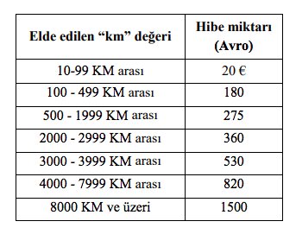
Funding per day: The amount of support provided per day per country is determined by the National Agency (www.ua.gov.tr).

EU Grant support for the Mobility of staff
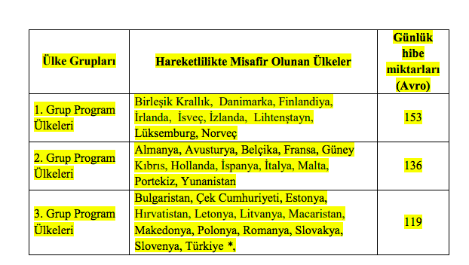
Table 1: Daily Amounts for Erasmus+ Teaching/ Traing Staff Mobility
Duration of mobility

The minimum duration for Erasmus+ Mobility for teaching is 2 days and the maximum duration is 5 days.

In all cases, a teaching activity has to comprise a minimum of 8 hours teaching per week and you must be a full time faculty member to apply. If your teaching period is more than 3 days, your teaching activity has to comprise minimum 10 hours.

In order to be eligible for the subsistence grants, beneficiaries will need to make travel arrangements for their mobility period up to one day before and one day after the actual teaching mobility dates.

How to apply

To be able to participate in teaching staff mobility, your Department/School/Faculty/Institute must have a valid agreement with the partner institution you intend to visit. If you wish to visit an institution that is not yet our partner, we urge you to contact your Department’s / School’s / Faculty’s / Institute’s Erasmus Coordinator to initiate the procedure for signing a new agreement. Please note that an institution must have an Erasmus Charter to be able to take part in this mobility. The list of all institutions with Erasmus Charters is provided at: https://eacea.ec.europa.eu/erasmus-plus/actions/erasmus-charter_en

Faculty members should contact the corresponding department of the partner institution, communicate and arrange his/her own Erasmus exchange visit. The host institution may assist you in finding on or off- campus housing and send you an invitation letter for the visa, if needed.

To be able to participate in training staff mobility program, there is no need for an Erasmus+ agreement between AGU and host institution. All full-time academic and administrative members who wish to take part in this mobility program should send approved (signed and sealed) program (completed) with invitation letter.

All teaching and administrative staff who wish to take part in staff mobility should send, via e-mail, application form, Staff Mobility Form, invitation letter, work plans, the names of the partner institution and the academic unit they wish to visit, and the expected dates of their mobility, to erasmus@agu.edu.tr no later than deadline.

Staff Mobility Criteria for Teaching and Training

Applying to the Staff Mobility for the first time | +20 Points
Previously participation to the mobility | -10 Points
Having completed at least 2 years at Abdullah Gül University | +5 Points
Staff with disabilities are prioritized (The statement from a doctor or other relevant authority confirming the special needs should be submitted to the International Relations Office during the application period) | + 10 Points
Spouse and/or Children of martyr people and/or veteran staff members are prioritized (if proving documents are provided in the application) | + 15 Points
Being an Erasmus Faculty/Department Coordinator in time of application | + 10 Points
Application from a non-active department within the Erasmus+ Programme | +10 points
If there has never been a participation from any of the AGU staff to the Receiving University before | + 10 Points
If there has never been a participation from any of the AGU staff to the Receiving Country before | + 10 Points
To have made an Erasmus+ Inter-institutional agreement on behalf of the Department | + 10 Points
English Proficiency Certificate or graduated from a %100 English Department | + 10 Points
Participation in Erasmus Programme in the country of nationality | -10 points
Compliance with the Internationalization Strategies and Aims of Abdullah Gül University as outlined in the Erasmus+ Charter for Higher Education 2014-2020 and its Internationalization Strategy | + 10 Points
Applicant who was selected but cancelled his/ her application after the deadline given by Erasmus Office in his/her previous application. (whether the reason is force majeure or no., the reason should be consulted to the National Agency and evaluated by the relevant Erasmus+ Commission of Abdullah Gül University) | -10 Points

P.S: All applicants will present their mobility details in the committee meeting. (5 minutes)

Any AGU member wishing to do so may take part in staff mobility without requesting financial support.

Applicants, who will not be awarded a grant on the basis of lack of funding, will remain on a reserve list and will be awarded grants if funds become available in due course.

Please visit www.erasmus.agu.edu.tr for information regarding partners, Erasmus+ coordinators, sample of documents and other related issues.

If you need any further information please do not hesitate to contact us via e-mail erasmus@agu.edu.tr.

